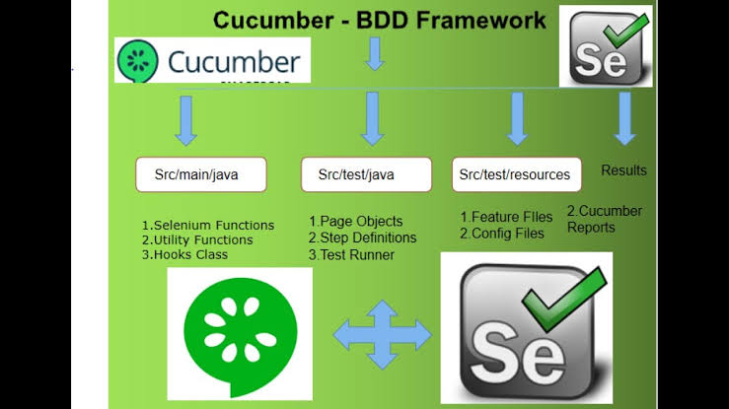

**Cucumber** is a testing tool that supports **BDD(BEHAVIOR DRIVEN DEVELOPMENT) framework.**

In BDD we first define the behaviors(functionalities) of the application/feature(epic), then do development based on that behaviors.

**1.** We define application behavior in English by **Gherkin language** in the feature file to make sure that the test cases are understandable for each member in the team. Even it is understandable for non-technical team members.

**2.** Then we write the JAVA/Selenium code

**Example: Login Functionality**

